STEWART ROME
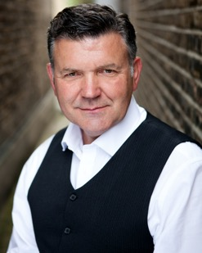
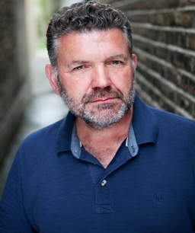

Height: 5’10”
Playing Age: 48 – 53 | Stocky Build
Tel: +44 (0)780 389 5823

Agent: https://www.marylizmanagement.com/
Tel: +44 (0) 203 856 0340
Spotlight: https://www.spotlight.com/profile/6695-0168-7965
Bases in both London & Manchester. Equity & BAFTA Member.

About
Returning to the profession in 2020 after a long career diversion, Stewart originally trained at Bretton Hall College and performed and produced professionally for 5 years in theatre and TV (under his legal name, Ben Green). This was followed by an impressive 20-year stint at the BBC: not only in production (development and producing), but as Head of Rights Business Development where he led the rights negotiation strategy and implementation for BBC iPlayer, and countless other archive projects.
Since returning he has been re-training at The Actor’s Café, Watford; performance workshops with Punchdrunk Theatre, London; ‘Screen Acting’ courses with James Larkin and Sarah Jayne Butler; and an 8- week online course with the BGB Studio, North Hollywood, US.
Training
Bretton Hall College (Leeds University) – BA Honours Theatre Arts (1984-87)
The Actor’s Café, Watford – Advanced Acting Course (Weekly class, Jan 2020- July 2021)
Screen Acting – Courses with TV Director James Larkin, and coach Sarah Jayne Butler
8-week online course with the BGB Studio, North Hollywood, US (Autumn 2022)

Recent Work
Year Role Production Director Company

2023 Mr. Beck DJ Kill Anton Makon Indie Film

2023 County Judge The Law According to Lidia Poet Frank Loman Dub Intl. / Netflix
(UK Dubbing)
2022 Dandy Waterloo Teeth Gillian Harker Indie Film

2022 King Martin Heirs To The Land N/A Dub Intl. / Netflix
(UK Dubbing)
2022 Head of
Security Turn Over Ting Tu London Film School

2022 CEO Protected Tom Chambers London Film School

2021 Henry There’s One Every Year Nick Alexander NFTS

2021 Carson (Lead) White Lands Markela Kontaratou London Film School
(Short Western)

Previous Roles (prior to BBC career)

Theatre
Role Production Director Company

Robert/ Bursting The Clouds Jonathan Church Profundis
MOD Official/ (Edinburgh Playhouse,
Veteran then 2 x UK National Tours)

Robbie Ross/ The Mirror of The Moon Jonathan Church/ Profundis
various (3 x UK Middle Scale Tours, Terry John Bates
incl. Kings Head London
& Library Theatre Manchester)

Lt. Wellbourne Rule of Three Simon Goodman Post Mortem
(Green Room, Manchester)

Robin Hood/ Various, as part of the Mark Wallis Reformation
Jouster/ Elizabethan Actors Company
Various at Littlecote Park, Berkshire

Roles during training at Bretton Hall included:
Richard in Pinter’s The Lover, Santee in Geography of a Horse Dreamer, and Ed Reiss in Torch Song Trilogy (NSDF Finalist)

Television
P.C. Andrews Brookside Jeff Naylor Mersey TV
P.C. Egan Coronation Street Richard Holthouse Granada TV
Doctor BUPA Commercial Unknown National TV

+ Various corporate training films including Royal Bank of Scotland & Halifax Building Society

Skills
Full Driving Licence (clean). Own car.
Stage Combat (including some sword-fighting, and some experience with black powder firearms)
Horse-riding
Improvisation
Baritone voice (can hold a tune)
Training & Presentations in Business
+ Much life experience via many different jobs over the years, at all levels - from building sites and factory work, to senior executive at the BBC

Accents
Native South East (Sussex), London (R.P. / East End), General American
Have also lived in West Yorkshire and Manchester so have some knowledge of these

