C L A I R E D R I V E R
http://clairus99.wixsite.com/clairedriver

LONDON-BASED

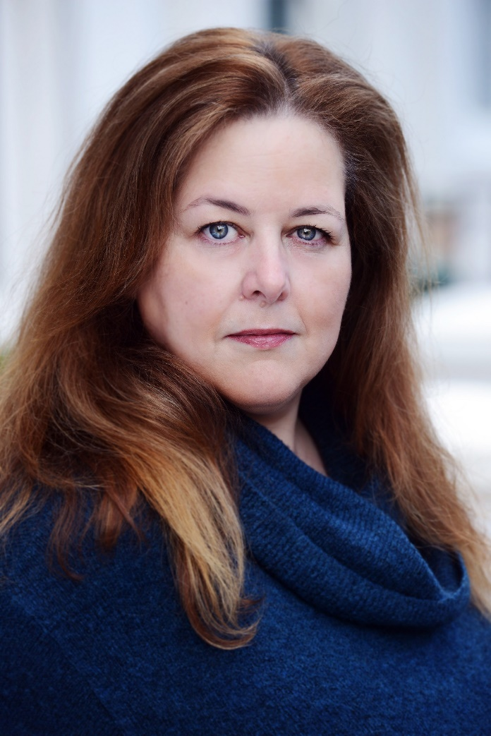

PERSONAL INFORMATION
Height: | 5' 6" | Hair: | Brown | Eyes: | Blue-Green
Vital statistics: | 49-42-48 | Dress size: | 18 | Shoe size: | 6
Age range: | 43-55 | Vocal range: | Mezzo/Alto (G2-E5) | Accent: | Native London (Estuary)

STATEMENT
I have worked in the entertainment industry for nearly 30 years, in different capacities - as an actor/SA/model/booker/DJ/Voice Artist, etc.
I pride myself on being patient, professional, reliable, and open-minded.

Full UK Driving Licence

Current DBS Certification
TRAINING  - 2 years Lee Strasberg Institute (London) Mariana Hill/David Bennett  - Courses at: The Actors' Centre (London), City Lit (London).  - Member of Lost Theatre, Waterman’s Art Centre with Chris Barton.  - 4-month course at The Theatre Factory (London) with Michael Wycherik.  - BA (Hons) Drama and English (Surrey University)  - Gravy for the Brain Member since 2018  MISCELLANEOUS  SM Dark of the Moon (Lost), Writer/Dir Lost Cause Revue (Lost), Asst Musical Dir Love of a Nightingale (Theatre Factory), Wardrobe/Design Street Cries (Camden People's Theatre), Co-Dir/Design The Box Office (Lost), Dir The Demon (St Margaret's), Sound The Road (Ata, Theatre Royal Drury Lane), Dir Rosencrantz & Guildenstern are Dead (St Mary’s). Performance Art: Jane & Louise Wilson (Undead Sun 2: We Put the World Before You), Naomi Fitzsimmons (The Vorticists). |  | PHOTOGRAPHIC WORK  Editorial character photographics - Bella, Best, Take a Break, Woman, Sunday Times, That's Life (Photographers include: David Lane, Robin Beckham, David Porter, Tim Sullivan, Bill Norton, Rory Carnegie). Examples upon request.  MUSIC  Alto. Blues, rhythm'n'blues, jazz, rock, pop, gospel, soul, choral, acapella, operetta. Able to read music, good with harmonies, learning songs/music fast. Member of band Rim of the World (1994-1996). Mobile DJ (CD/MP3) and Karaoke Host since 2002.  VOICE  Home Studio – Focusrite Scarlet 2i2 Studio Pack.

ACTING EXPERIENCE (Highlights and most recent listed, full list available upon request or view full list online)
Theatre
PRODUCTION | ROLE | DIRECTOR | COMPANY
Love in a Wood | Martha | Tim Keenan | Theatre Factory
Love of a Nightingale | Vocalist | Andrew Potter | Theatre Factory
Merthyr Girls | Jan | Bethany Parry | Lost Theatre
Threepenny Opera | Mrs Peachum | Cecil Hayter | Lost Theatre
Vanity Fair | Matilda Crawley | Cecil Hayter/Terry Hawes | Lost Theatre
Cinderella (Panto) | Malodera von Bjitch | Julian England | Lost Theatre
The Final Choice | Lizzie | Tamzin Houghton/Chris Barton | Waterman’s Theatre
Womberang | Rita | Tom Reid | St Margaret’s Theatre Co
The Road | Little Egypt | Fiona-Jane Pethick/Mark Nuti | Ata Productions
Comedy of Errors | Duke Solinus/DJ | Mark Griffin | St Mary’s
Bright | Pam | Stuart Gearty | St Mary’s
Peacemaker | Mister Man | Mark Griffin | St Mary’s
The Rise and Fall of Little Voice | Sadie | Jai Sepple | Strictly Theatre/Brookside
Suff’ring | Helena | Mark Bittlestone/Will Penswick | StraightUp Productions
Space Doctor | Dodo Chen | Will Dalrymple/Will Penswick | StraightUp Productions
Space Doctor | TV Critic (Media) | Will Dalrymple/Will Penswick | StraightUp Productions
The Ghost Hypothesis | Miller | Victor Correia | Horatio Productions
Press Cuttings | Mrs Farrell | Carrie Cable | Putney Arts
A Chat with Mrs Chicky | Mrs Holbrook | Carrie Cable | Putney Arts
Macbeth | Doctor | Ian Higham | Putney Theatre Company
Ear for Eye | Contributor (Media) | Debbie Tucker Green | Royal Court/Fruit Tree
All My Sons | Sue Bayliss | Mair Graham | Richmond Shakespeare Soc
Film/TV/Video/Voice
PRODUCTION | ROLE | DIRECTOR | COMPANY | MEDIA
Howard's End | Soup Seller | James Ivory | Merchant Ivory | Feature Film
Hearts of Gold | Car Crash Victim | Jane Topping | BBC | TV
Two Golden Balls | Decoy for Sydnie | Anya Camilleri | Bard Entertainment | Feature Film
The Big Idea | Mother Earth | Fiona Law | Diverse Productions | TV
Harry Enfield & Chums | Harridan | Dominic Brigstocke | Tiger Aspect | TV
Stella Does Tricks | Angry Customer | Coky Giedroyc | Stella Does Tricks Prod | Feature Film
TFI Friday | Demi Moore | Simon Stafford | Ginger | TV
Super Furry Animals –  "Hermann Loves Pauline" | Pauline | Mark Nunnelly | Live from Bermuda | Music Video
Dispatches – "Dirty Doctors" | Sharon | Howard Bradburn | Twenty Twenty | TV
Lucozade - "Full Mountie" | Fat Slag (Sandra) | Mark Woods | Godman Films | Commercial
Zeitgeist | Louise Woodward | Ed Braman | Clark TV | TV
The Bill | Susan | Christopher King | Talkback/Thames | TV
If...We Don't Stop Eating | Maureen | Richard Curson Smith | Blast! Films | TV
Death by Excess | Cass Elliott | Molly Milton | Oxford Scientific Films | TV
Extreme Ghost Stories | Janine | Paul Bithrey | Granada Factual | TV
At Night | Wife | Adam …… | Silver Productions | TV
Black Sabbath - "God is Dead?" | God | Shynola | Shynola | Music Video
Shipman: Catching Dr Death | Primrose Shipman | Nick Aarons | Crackit! Productions | TV
Grimsby | Pub Regular | Louis LeTerrier | Four By Two/Sony | Feature Film
Trendy | Claire | Louis Lagayette | Trendy Films | Feature Film
Angles | Florence | J F Balcazar | London Film School | Short Film
The Faction of Farce:  Plastic Fantastic/Maternal Truth | Kimberley/Frieda | Ross K Foad | Ross K Foad | Internet Channel
Ending the Awkward | Customer | Adam Finch | Scope/Southern Co-op | Corporate
MS Enough: Small Changes | Belinda | Ben Noble | In House | Corporate
Age UK | June | Johnny Mindlin | Green Shoot | Corporate
Sugar! | Neighbour | Howard Stean | Arepo Productions | Short Film
Depths of the Bottle | Jennifer | Jordan Woodley | JW BU | Radio Drama
Scared | Lia’s Mother | Kiran Hudson | Liz Pictures | Short Film
Blue Roses | Edwina | Frank Stanwyck | Uranus Pictures | Short Film
Diagnosis | Denise | Abbie Jemsen | Greenwich | Short Film
Employee of the Month | Customer 2 | George Watton | Hennessey | Short Film
The Liar | Patricia | Jack Salvadori | Royal Holloway | Short Film
Greenhorn | Angela | Kelly Pyner | Ravensbourne | Short Film
I Am… | Therapist | Becky Downes | LSBU | Short Film
Trojan Horse/Rainbow Flag | T- | Ian Giles | videoclub | Art Film
Adventures of Captain Awesome | Sarah | Jacques De Vere | BUFP | Short Film
Visiting Mum | Mum | Rachel Kitkat | RK BU | Radio Drama
Learning to Fly  Financial Crime  Catching a Killer | Julie  Judge  Jennifer | Sam Harrop  Dale Campbell  Bill Thomas | LMU  Still Moving  Arrow Media | Short Film  Corporate  TV
Thirteen Cars | Leon’s Mum | Rob Woods | Silent D/London Boy | Feature Film

