- NIGEL MERCIER
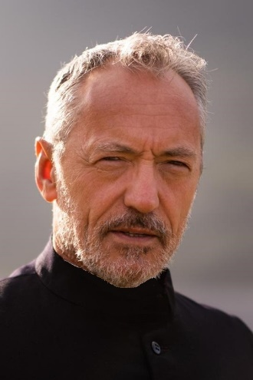

NATIONALITY Irish
CONTACT +353(0)87-765-9634
nigel.mercier@gmail.com
PLAYING AGE 55-65
WT 12 stone
HT 5’9”
HAIR Grey
EYES Brown
AWARDS:
Best Actor of the festival ALTFF Toronto June ‘22
Best Acting (honourable mention) London International Monthly Film Festival. July ‘22
Numerous nominations

CREDITS ON NEXT PAGE…

Year | Type | Role | Company | Production name | Director
2018 - 2023 | Television | D.I. Steve Yates | RTE | Fair City | Various
2023 | Short Film | Jimmy | Carbonated Comet | A Holy Show | Jamie O’Rourke
2022 | Commercial | Lead | Ad Vantage | Fairco | John Gleeson
2022 | Short Film | Fr Ryan | Dolmen Film | The Cathedral | Turlough O'Cinnéide
2021 | Television | Sal O'Malley | Kiyo prod | Groundbreaking | Patrick William Smith
2021 | Television | ERU Commander, John | RTE/Saffron Moon | Hidden Assets | Thaddeus O'Sullivan
2020 | Television | Ned Hutchins | BBC/Treasure Entertainment | Smother | Daithí Keane
2018 | Television | HMSU Commander | Hat Trick / JM Prod | Bloodlands | Pete Travis
2018 | Feature Film | Dr Gerrick | Babyjane Prod | The Martini Shot | Stephen Wallis
2018 | Feature Film | The man | Greenflash Pictures | Night Shift | Stephen Hall
2017 | Feature Film | Rodney | Picture Perfect | Hexing | Christophe Lenoir
2017 | Television | Essam Eid | TFPTK Films | Assassins | Keith Farrell

