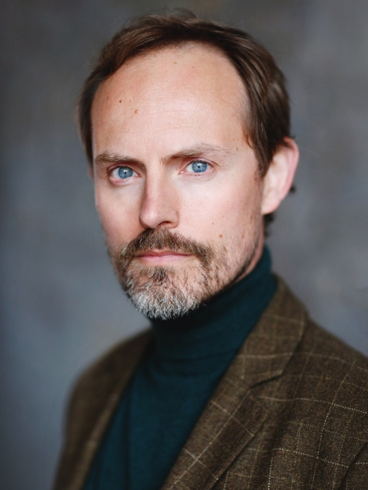
TIM LARKFIELD
Spotlight: https://www.spotlight.com/3811-6725-0292
E: tim.larkfield@gmail.com
Agent: Brian at Brood Management
Contact: T: 020 7998 7861
E: broodmanagement@aol.com

Location: London / Margate, UK
Playing age: 34-44
Height: 5’11” (180cm)
Weight: 12st (75lb)
Eyes: Blue
Hair colour: Blond / light brown
Hair length: short

Training: The Poor School, London, Two-year training

Accents: London (native), RP, Cockney, Estuary, General American, Southern American, Yorkshire

Theatre includes:
2021, Conductor, THE POLAR EXPRESS, PNP Events
2021-2023, Various roles, PLAY DEAD LONDON, murder mystery company, Dir. Emma Crocombe
2019-2020, Signalman, THE SIGNALMAN, Old Red Lion Theatre / New Normal Fest / The Space, Dir. Sam Raffal
2016-2019, Improviser, THREE WORLDS, Dir. Andrew St John
2018, Victor Prynne, PRIVATE LIVES, Shooting Stars Theatre, Dir. Jonas Cemm
2018, Tim, GAPS, Dir. Matt Strachan
2017, Andrew Thompson, THE SILK OF 1,000 SPIDERS, Icon Theatre, Dir. Nancy Hirst
2017, Dodo / King of Hearts, ALICE, Dir. Charlotte Jacobs
2017, Mr Hunter, GROSS CAPITAL, Dir. Jack Saville
2016, Phil, JUST DO RIGHT, Atramental Theatre, Dir. Eddie Howell
2016, Chris, BETWEEN A MAN AND A WOMAN, Dir. Scott James
2016, Soldier, WE’RE HERE BECAUSE WE’RE HERE, National Theatre, Dir. Jeremy Deller & Rufus Norris

Television and Film includes:
2023, Mr Friend, THE MYSTERY OF MR E, Landrigan Entertainment, Dir. Martyn Tott
2023, Cyril, APPLAUSE, NFTS, Dir. Marie Lemaire
2023, Greg, FRUIT LOOPS, Jack Judd Films, Dir. Jack Judd
2022, Jason, OPEN, White Stag Films, Dir. Richard Paris Wilson
2022, Trevor, MAYA’S MOMENT, Yellow Pill / Xiaomi Studios, Dir. Michele Fiascaris
2022, Jim, STAY, Hayling Studios, Dir. Jack Ndupuechi
2021, Adult Christopher, DETER, London Film Academy, Dir. Tibet Boyer
2021, Dr Langston, THE PERSISTENCE OF MEMORY, London Film Academy, Dir. Susanna Newman
2020, Michael, NOT FAR FROM THE JUNCTION, Open Pen, Dir. Will Ashon, Sean Preston
2019, Radio Announcer, I DON’T WANT TO SET THE WORLD ON FIRE, Elias Films, Dir. Marcus Liversedge
2019, Simon, TEETH, Dir. Jennifer Martin
2019, David, THE PIANO IN THE OLD FRONT ROOM, Outer Dark Pictures, Dir. Reuben Vick
2018, Lieutenant Bergen, ALCATRAZ, North Bank Entertainment, Dir. Andrew Jones
2017, Alan Turing, LET’S DO PHILOSOPHY, KBNE-UK, Hyung Joon KIM
2017, SS Officer Streicher, WEREWOLVES OF THE THIRD REICH, North Bank Entertainment, Dir. Andrew Jones
2017, Dad, NO SUCH THING AS MONSTERS, Met Film School, Dir. Jonathan White
2017, Ford, SILENT LIGHT, Ravensbourne, Dir. Thomas Potter

Corporate / Commercial work includes:
2022-2023, Expert/Presenter, RAILWAY TRAINING VIDEOS, Firewood Pictures, Dir. Will Dolan
2022, Presenter, INTERACTIVE MATHS PROJECT, Sneak Global, Dir. Martin Percy
2021, Torvald Helmer, DECISIVE MOMENT, NFTS, Dir. Alexandre Do
2020-2021, Presenter, CHURCHILL PARTNERS, Dir. Jamal Khan
2020, Parent, VACCINE CONCERNS FILM, Liquona, Dir. Amanda Ward
2019, Nurse, NHS TRAINING VIDEOS, Sightline, Dir. Keith Thomas
2018, Jamie, LIDL CHRISTMAS PARTY SNACKS, Smuggler, Dir. Michael Clowater
2017, Stuart, FIRST LOVE FOUNDATION - I AM, Yeti Productions, Dir. Isaac Bell
2017, Simon, DOGS TRUST CHRISTMAS FILM, Blindeye Films, Dir. Jack Lightfoot
2017, Business owner, NATWEST ANTI-FRAUD, Light Creative, Dir. John Randle / Ant James
2016-2020, Various roles, CIVIL SERVICE TRAINING VIDEOS, Sightline, Dir. Keith Thomas
2016, OB Reporter Steve Brown, JAEGERMEISTER ZOMBIE OUTBREAK, Silverdoor, Dir. Chris Hornby

Other training and skills:
- Broadcast journalist (BBC) – Voiceover, TV News reporting/production, Digital Video, Radio
- Improvisation: Play Dead London / Three Worlds
- Rehearsed reading: Member of Liars’ League
- Puppetry – Little Angel Theatre
- Voice training
- Movement and physical theatre, including Laban
- Singing – Musical theatre (Baritone / Tenor)
- Period dance
- Clarinet
- Full driving licence

