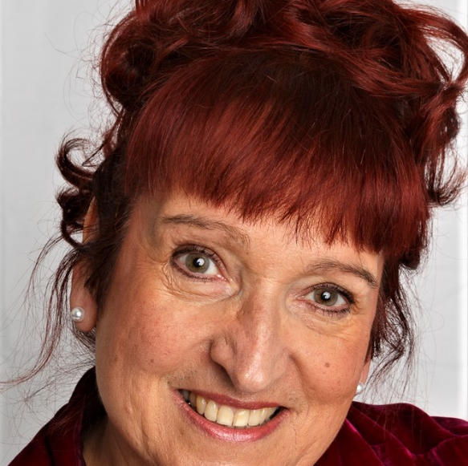
Lena Richardson Actress
Rep`d by Cherry Parker Management agents@cherryparker.co.uk
Spotlight https://www.spotlight.com/9972-1209-6383

- 01702 522647
Contact
www.spotlight.com/ 9972-1209-6383

Reee

About
Award winning Actress in film, with many years as a stage actress in musicals and drama. Trained at Mountview for 3 years. Mezzo Soprano. Director and Choreographer. Created & performed in touring Revue Company for 6 years.

Year | Film | Role | Director / Company
2024 | 3 Wishes for Christmas | CAA Guard 1 | Michael Morris/ M and M Film Productions
2023 | Escape | Margaret | Howard Ford/Latitude Films
2023 | Ash Sunday | Laura | James Alexander Allen
2023 | The Butcher | The Butcher | Liam Bolton
2023 | Dissonance | Emma | Caitlyn Parr
2023 | The Monster | Violet | Simba Masuku/ SimJimmFilms
2022 | TORN | Tina | Emily Sewell
2022 | Museum Piece | Museum Guide | Steven Lancefield/Half Moon Prods
2021 | Ex’s Anonymous | Hyacinth | Obie Dean / Silent Dove Pictures
2021 | Edge of Insanity | Newsreader | Luke Martin
2021 | Platonic Drift | Jackie | Youngdae Lee
2021 | Bingo with Betty | Nan | Peter Palmer
2020 | The Greatest of Expectations | Katrina | Freddie Hill / Graded Films
2020 | A Bitter Pill | Receptionist/Radio Host | Luke Martin
2020 | A Final Goodbye | Margo Collins | Freddie Hill / Graded Films
2018 | Moira | Moira | Eugene Doyen

Year | Online / Digital | Role | Director/Company
2023 | Hrimfaxi Adventures | Cmdr Kara Windrider | Makrenna Standen
2022 | Greene King Commercial | Featured Staff member | Martin Greene/M Greene Assoc
2022 | Loving Tribute Commercial | Lead Actor | Freddie Hill/Graded Films
2022 | Love`s Poison | Audiobook Actor | Wayne Liversidge
2021 | New Musical R&D | Fishwife / Inventor | Benjamin Froelich / NTC
2021 | To Be Honest (TV Pilot Read) | Claire | Emily Isaacs / ODD Content
2021 | Rushes | Carly | Steven Lancefield / Cockpit Theatre
2021 | Let Me Not Know | The Wife | Anita Tucker
2021 | Agenda | Cathy / Chairman | Tabitha Wells/Directors Cut
2021 | Zombies | Lucy / Maths Teacher | Bryony Tebbutt/Directors Cut
2021 | The Ice Palace | Narrator | The Little Bookshelf
2020 | Drinks Coach App | Featured artist | Anita Ncube/Archant Video
2020 | Rainbow | Shelley | Bruno Caterino / Cockpit Theatre
2020 | Jakes Room | Sarah | Troubadour Theatre
2020 | Harry Stays At Home | Narrator | NGK Books
2020 | When It Rocks | Laney | Sapphic Voices / Radio Reverb

Year | Theatre | Role | Director / Venue
2022 | RISQUE | 4 characters | Murray Hecht/ Brighton Fringe
2019 | New Faces Music Hall | Music Hall Performer | Jan Hunt / The Players Theatre
2019 | Hunters of Ghost Hall | Bonnie | Brighton Fringe / Most Curious Pro
2019 | The Thrill of Love | Sylvia Shaw | Susan Goble / Swallows Theatre
2017 | Blithe Spirit | Madam Arcati | Nicci Pennicott / Memorial Theatre
2017 | A Merry Regiment of Women | Kate / Shrew | Petworth Fringe / Cowdray Ruins
2006-12 | The Allsorts Revue | Music Hall Performer | Various / South England Tour
2011 | Annie | Miss Hannigan | Caroline Bennet / Windmill Theatre
2000 | Charlie Girl | Kay Connor | The Harlequin Theatre
1996 | Applause | Margo Channing | Jon Taylor / Epsom Playhouse
1995 | Sweet Charity | Charity | The Adrian Mann Theatre
1994 | Kiss me Kate | Kate | Epsom Playhouse
1994 | Anything Goes | Reno Sweeney | Secombe Theatre, Sutton
1990 | Mame | Mame | Jon Taylor/Epsom Playhouse
1988 | Cinderella | Dandini | UK Tour / JME Productions
1983 | The Menin Gate | Actor/Singer | Bristol Hippodrome Royal Variety
1983 | Aladdin | Principal Girl | Lisa Baron / WSM Playhouse
1982 | Once in a Lifetime | Helen Hobart | Ed Stern / Victory Theatre Ohio

