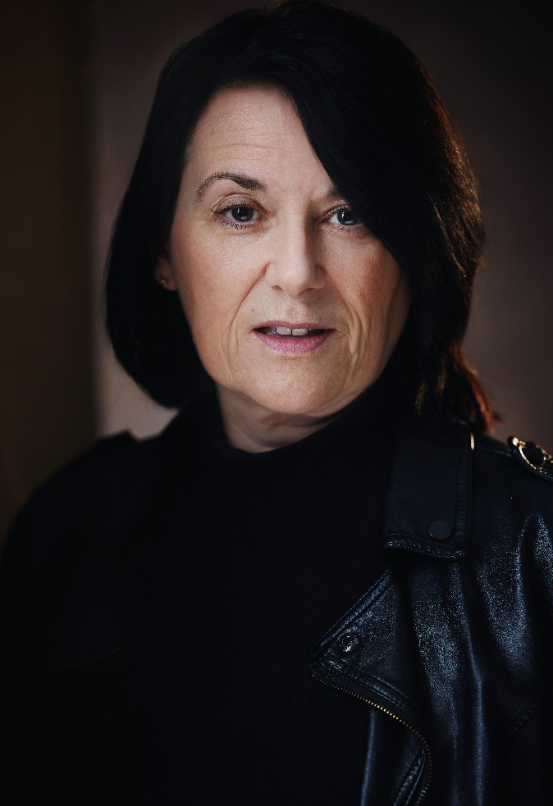 |  | Sara willats  Actor and Model based in London
Profile  I am a confident and reliable London based actress with 4 years experience in TV, film, adverts, modelling and music videos.  Contact  PHONE:  07984 418550  EMAIL:  Saraw441@outlook.com  spotlight pin  9217-3496-3962  skills  Fluent in French and Spanish  Can cry on cue  Professional, hard working and passionate.  Clean car license and own car |  | 2025 Upcoming  Hazel in The Children by Lucy Kirkwood at the Barn Theatre  2024  Monologues for A Woman over 40 performance at Libra café  Customs Officer with lines in Feature Film No Time for Goodbye  Lead role of Ann in short film Do Unto Yourself  Maid in Twin Flames web series for the US  Politician in Ecosia marketing campaign  Corporate model for Caia library images  Grace Season 4, ITV - Passerby with car  A Killer Makes a Call, Channel 5 - Dawn Lewis  Masked Singer, ITV – stunt performer (Eiffel Tower)  Big Mood channel 4 – feature in one episode  Investor in HSBC modeling campaign  Expereo One - Corporate video  2023  Nirahua Hindustani 4 feature film – Jack’s mum  Behind the Door, Metschool film – Tilly (lead)  Lead in various student films  G Choppa rap video – Dancing Granny  2022  Silo, Apple TV – Stand in for Angela Yeoh  Holby City, BBC1 – body double with prosthetics for Jenny Howe  Hinterview Ltd, Corporate video – Ellie Palmer  97 Minutes feature film – featured hostage  Funeral student film – Greek  I’m Not Being Melodramatic student film – Nurse Maria

