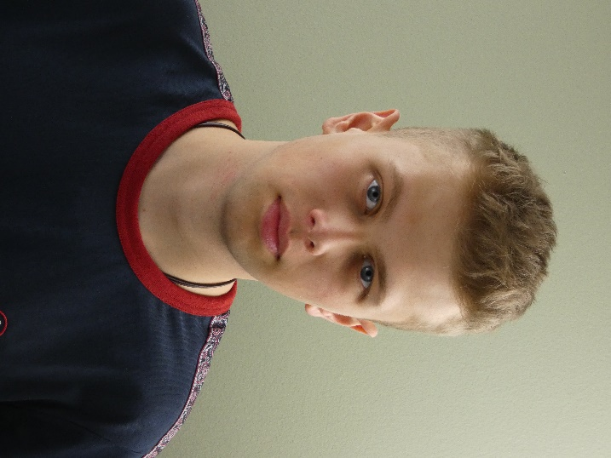
H.G. Whaley
Phone: +44 07546 743837 | Email: hgwhaley@outlook.com
Date of Birth: 06/09/2006 | Nationality: British/Welsh
Spotlight Instagram X
VShowCards

Agent
AP Talent Management
Tel: +44 7828 164621
Email: info@aptalentmanagement.co.uk

Personal Profile
A versatile and dedicated actor with experience in stage, television, and short films, delivering compelling performances in leading and supporting roles. Skilled in dramatic techniques, line memorization, and a range of accents and dialects, with a playing age of 16–21. Committed to collaborating with casts and crews to create cohesive and impactful productions. Actively pursuing opportunities in stage, film, and television.

Physical Attributes
- Height: 6’1” (185.4 cm)
- Hair: Dark Blonde
- Eyes: Blue
- Build: Waist 31”, Inside Leg 32”, Chest 38”
Acting Experience
Television
- Mammoth (BBC) – Dean (12/2023)
- It’s My Shout Productions (BBC) – Various Roles (08/2022 – 06/2023)
- Various BBC TV Shows – Extra (08/2022 – Present)
Stage
- We Will Rock You – Buddy, Actors Workshop, Chapter Arts, Cardiff (2021)
- Oliver – Bill Sykes, Actors Workshop, Cardiff (2019)
- Shakespeare On Trial – Master Ford/Master Brook, Bridgend College Level 4 performance, Bridgend (2025)
- Goldilocks and The Three Bears – Renni the Fire Eater, Arc of Entertainers, Crown Hill Community Centre, Pontypridd (2025)
Other
Stagehand
ARC of Entertainers, Crown Hill Community Centre, Llantwit Fadre, Pontypridd
February 2024 – February 2025
- Supported production by assisting with stage setup, scene changes, and equipment management.
Stagehand
Stardreams Musical Theatre Company, Tonyrefail, Rhondda Cynon Taff
April 2023 – April 2023
- Supported production by assisting with stage setup, scene changes, and equipment management.
- Coached performers on acting techniques, contributing to successful shows.

Training
- Acting Training, Actors Workshop, Cardiff (2018 – 2021)
- UAL Level 4 Performance Professional Diploma, Bridgend College, Bridgend (2024-2025)

Performance Skills
- Accents: British RP, Welsh, Cardiff, American-Standard, Birmingham, English-Standard, Irish RP, Liverpool
- Dramatic Techniques, Line Memorization, Storytelling, Character Development
- Playing Age: 16–21
- Developed on-set professionalism.
- Participated in professional TV productions, following direction to enhance scene authenticity.
Additional Skills
- Cycling, Rugby, Running, Swimming
- Bartending, Strong Verbal Communication, Creative Writing
- Car Driving Licence
Technical Skills
- Video Gaming, Photography, Filming, Media Production

Work Experience
Front of House Staff
I Love Moo.Cheesecake, Ton Pentre, Rhondda Cynon Taff (03/2025 – Present)
- Deliver exceptional customer service, greeting guests and addressing inquiries promptly.
- Maintain a welcoming environment by preparing and resetting tables efficiently.
- Collaborate with team members to ensure smooth operations during busy shifts.
Front of House Staff
The Ivor Arms, Brynsadler, Rhondda Cynon Taff (06/2024 – 03/2025)
- Provided attentive service, enhancing guest satisfaction through personalized interactions.
- Managed high-pressure situations, ensuring timely service during peak hours.
Casual Food & Beverage Assistant
Miskin Manor, Pontyclun, Rhondda Cynon Taff (01/2023 – 05/2023)
- Presented menus and recommended specials, boosting customer engagement and sales.
- Maintained high standards of cleanliness for glassware, cutlery, and dining areas.
- Responded to guest needs, resolving issues to ensure a positive dining experience.

Education
UAL Level 4 Performance Professional Diploma, Bridgend College (09/2024 – 04/2025)
UAL Level 3 Diploma in Creative Media Production & Technology, Nantgarw College (09/2023 – 07/2024)
Radyr Comprehensive School (09/2018 – 06/2023)
- GCSEs: Mathematics, English Language & Literature, Drama, Triple Science, IT, Media, Art, Welsh, Welsh Baccalaureate
Interests
- Creative Arts: Passionate about acting, filmmaking, and photography, with a portfolio of short films and creative projects.
- Writing: Enjoy crafting scripts and stories for film and theater.
- Music & Film: Avid consumer of music and cinema, staying updated on industry trends.

