Lee Alan Donaldson Spotlight:

<https://app.spotlight.com/9492-8944-7841>

Actor, Stunts & Producer IMDB:-   
https://m.imdb.com/name/nm14492018/

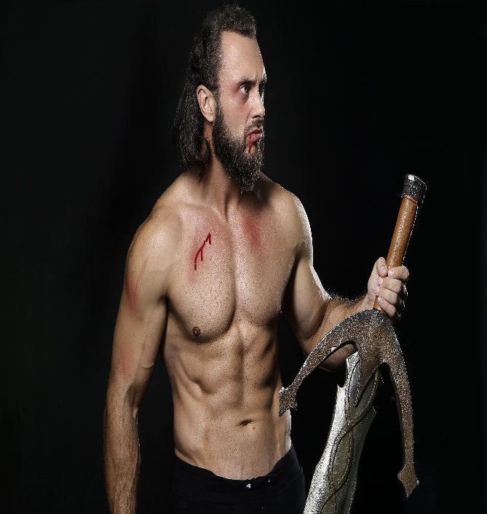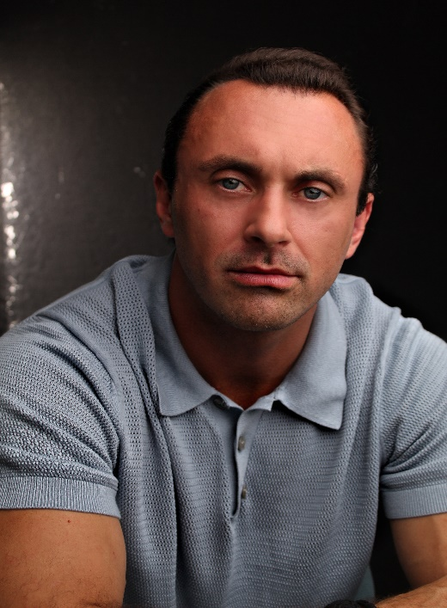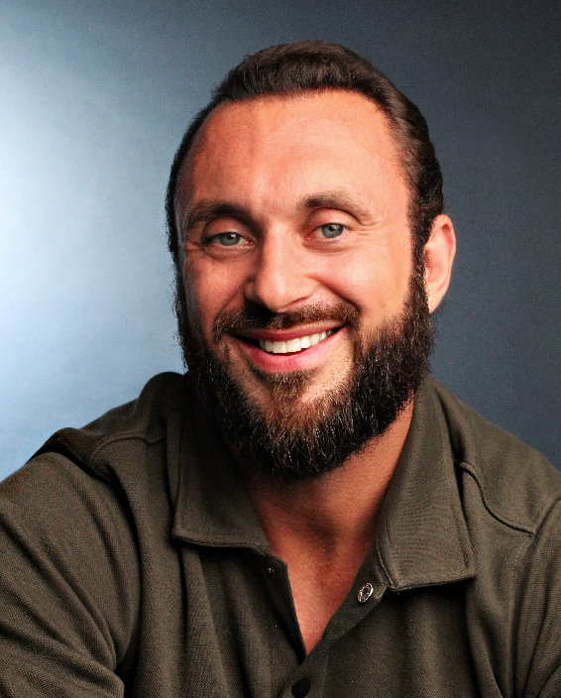

**Casting Personal Details**

Age: 36 – Playing Age 28-40 Accents: Essex -Cockney

Eyes: Blue RP – American Standard/

Hair: Long, Dark Brown Southern- Russian- Good

Build: Very muscular / Athletic ear for accents and dialects

**Training**  **Skills**

Wire work Firearms

Firearms Training Gymnastics

High Falls (up to 8m) Martial arts -Muay Thai & Bjj

Unarmed 1 on 1 & 1 vs 6 Advanced Weightlifting

Gladius, Cutlass, Spear & Shield Screen Combat

Longsword, Broadsword Ambidextrous

Mocap & Performance Capture Full UK driving licence

**Film & Tv Stats**

**Feature Films:** Ant Man Quantamania – Height 6”0

Masters of the Universe- Dead Zero Weight 95kg

**Short Films** **/ TV Pilots:** Jackal & Hide -The Imman Chest 44” Size L

The Soothsayer - Carp Light Collar 17”

**TV:** The Witcher Season 3, 4, 5 - Extraordinary Season 2 Head 22”

House of the Dragon Season 2 -The Ballard of Renegade Nell Waist 32-34”

Brittania Season 3 Inside Leg 30 R

**Gaming:** Humaning Shoe size 9