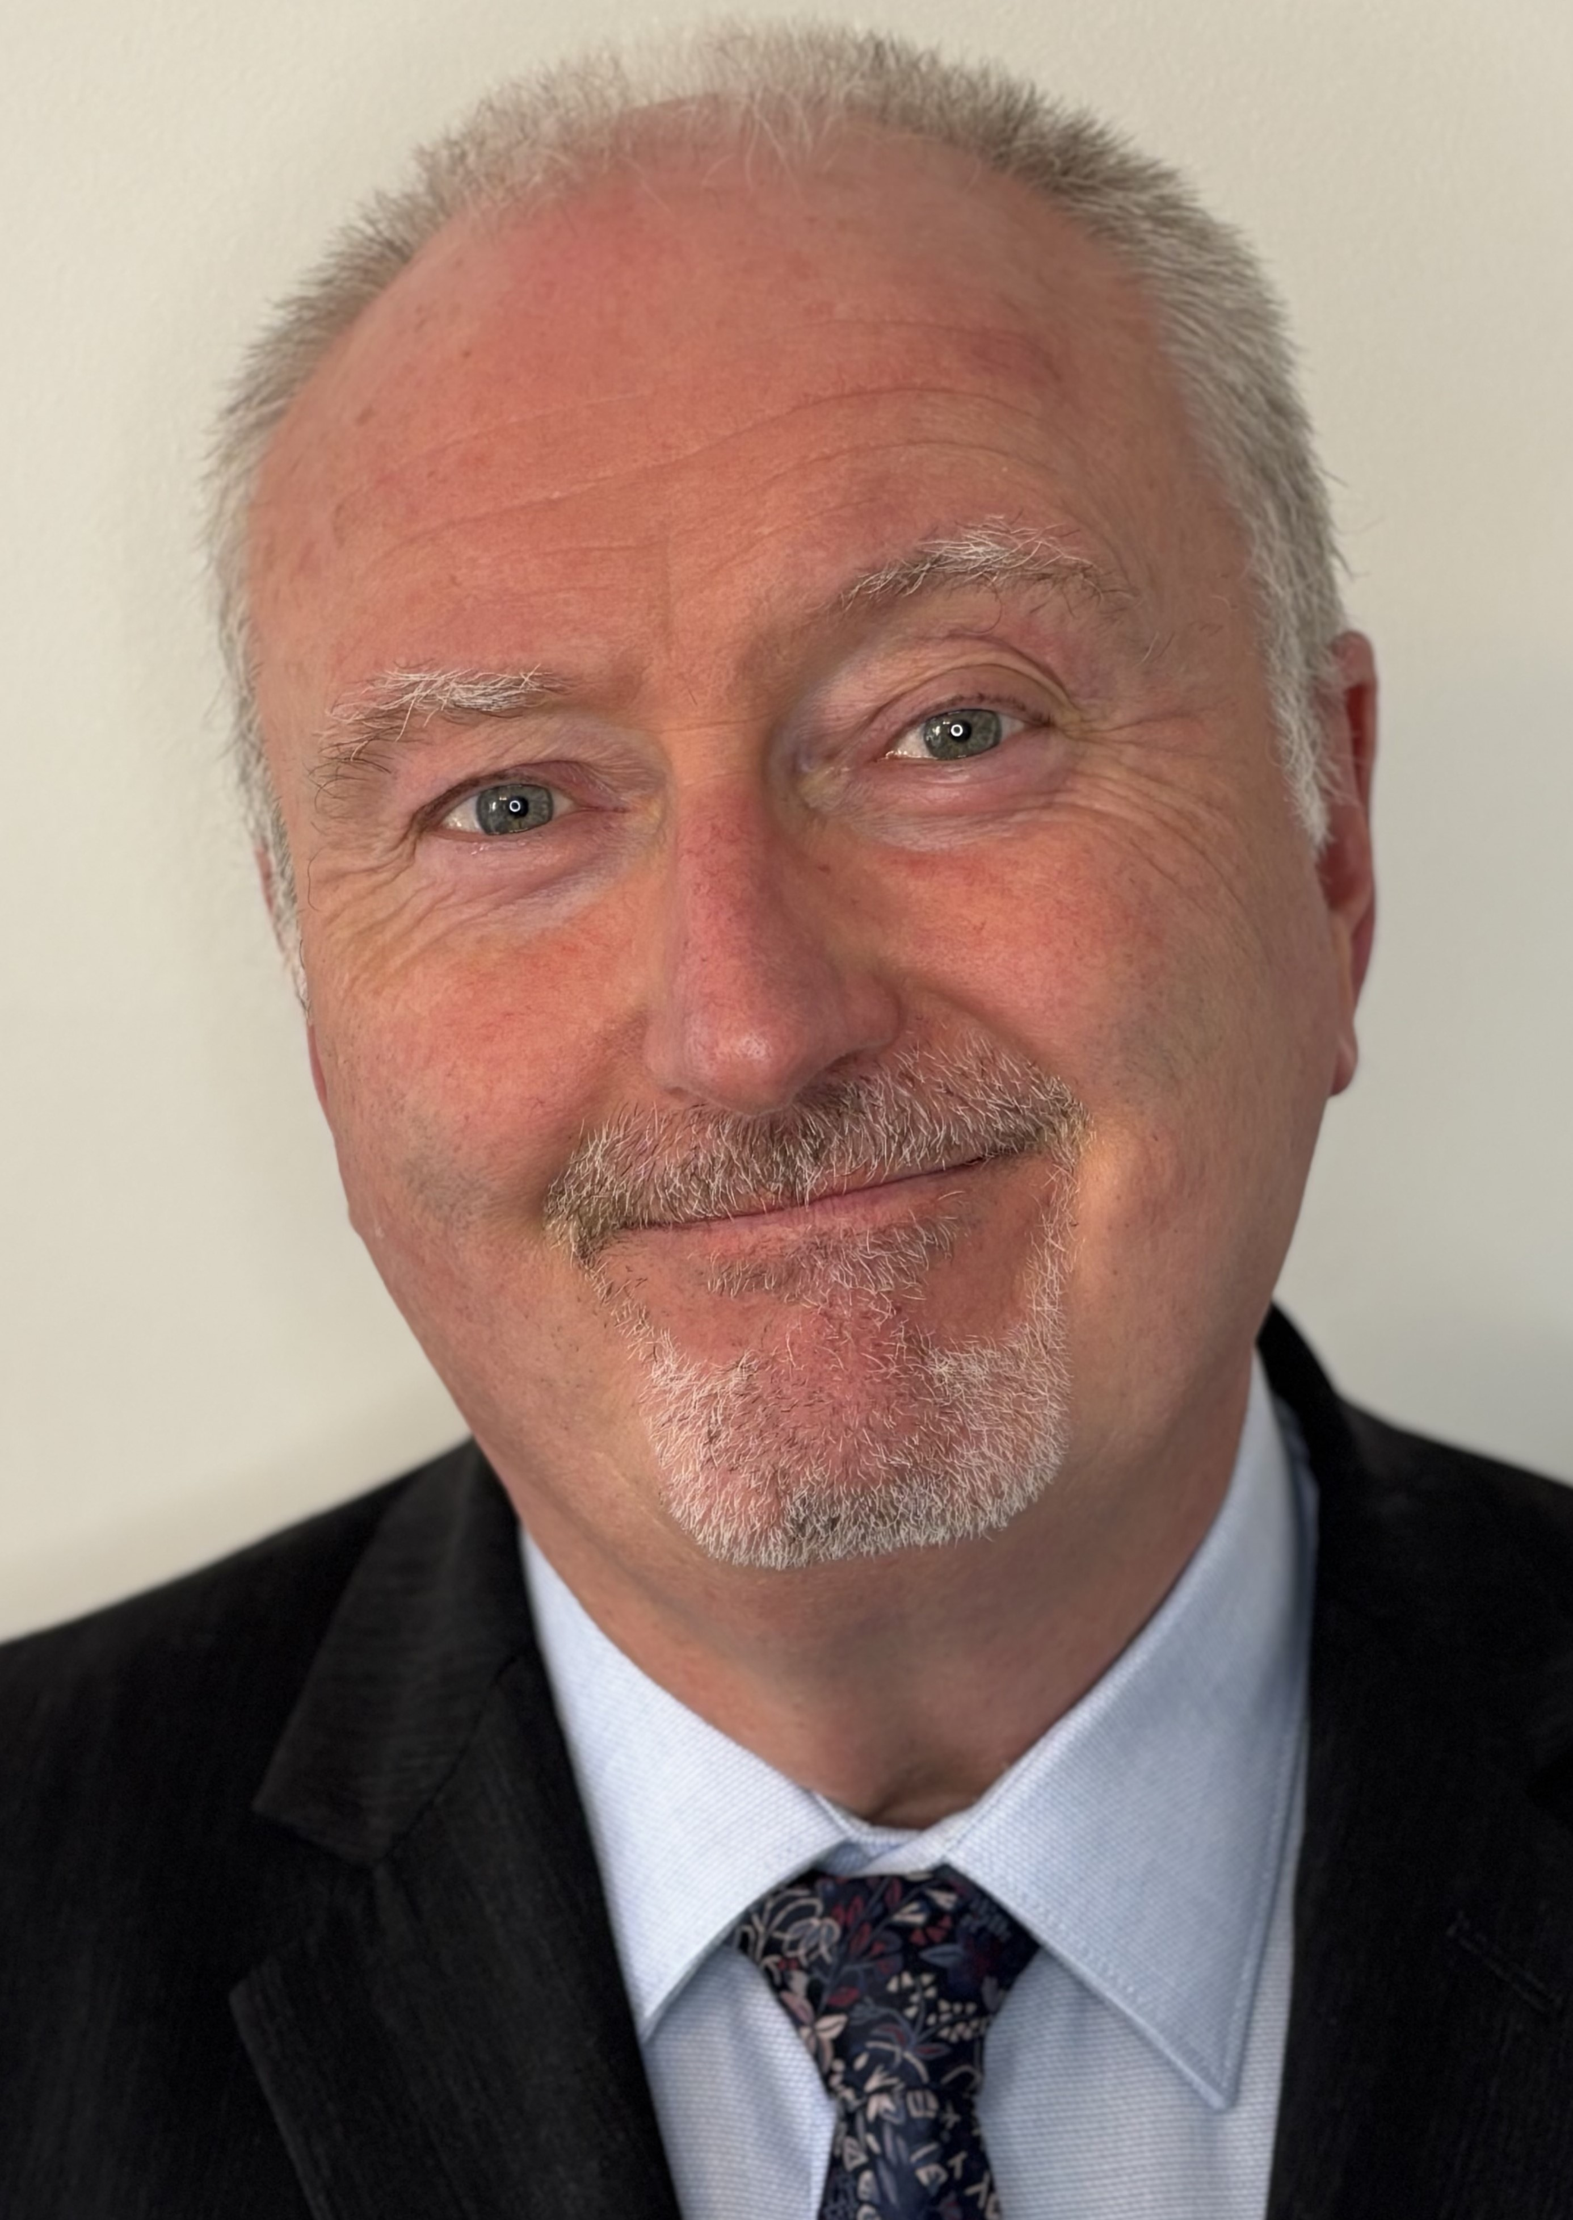

Mobile: 0777 348 4014

Email: [bernarddelaney@hotmail.co.uk](mailto:bernarddelaney@hotmail.co.uk)

Spotlight: <https://app.spotlight.com/1898-0169-9645>

Location: Manchester

Height: 1.78m

Hair: Grey

Eyes: Grey/Hazel

Accents: RP, Mancunian, Liverpudlian, Geordie, general Scottish

Role playing age: 56 – mid 60’s

**Personal Profile/Personal Attributes**

* Strong organisation skills and drive.
* Leading workshops in Drama
* Physical theatre skills
* Devising and improvisation
* Excellent interpersonal skills – Well presented, good communicator, high integrity, works well with others. Extremely reliable and dependable.
* Actor DBA checked – qualified secondary school Drama Teacher
* Clean driving licence

**Experience**

*Film – As Actor*

**Ruff & Ready –** Directed by Luke Walters, Bern Lafferty.48 Hr Film Festival. 2025

**The Dotted Line** – Directed by Phil Hawkins, Police Officer Collins. BBC funded project. 2006

*TV – As Actor*

**Hollyoaks –** Lime Picture Production, SA. 2025

**Run Away –** Quay Street Productions. Executive Producer: Harlan Coben. Professor character SA, 2025.

*Theatre – As Director*

**Monster** – Written by John Doona. Dukes ’92 Upper Theatre Venue, Castlefield. Manchester 2000

*Theatre – as Actor*

**The Crime of the 21st Century** – Written by Edward Bond (celebrated playwright), Directed by John Doona. Lead character of Grig. Dancehouse Theatre, Manchester 2002. This play was supported by the playwright who spoke to an invited audience post production.

**Ragged** – Directed by Grant Fairlie, written by John Doona. Main Character ‘Gunn’. Dancehouse Theatre, Manchester. August 1998

**Linger** – Written and Directed by John Doona. Lead character ‘Pep’. North Manchester Peoples Theatre (School site) 1997

*Radio – As Voice Actor/impersonator*

**The Glorious Get-together** – Written and Directed by Alfie Joey for Radio 4, the voice of Sean Connery as James Bond 1. Broadcast 2004.

**Education**

* BA (Hons) – Theatre and Media Studies Degree. Bolton and Manchester University 1995.
* PGCE – Drama – Manchester Metropolitan University, Didsbury, Manchester. 1996.