Iain Collins
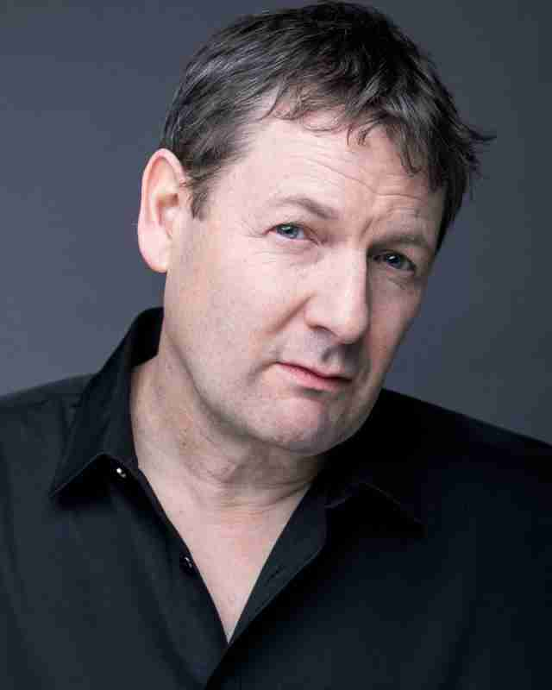

Telephone: 07751 995079
Email: mailto: iaincollinsactor@protonmail.com
Location: London
Playing Age: 40 to 50
Height: 180cms
Build: Medium
Eye colour: Blue
Hair Colour: Brown
Hair Length: Short
Performances

Production Role Company Director
Short Film

Old and Grey Nichols True Vision Features Louis Scott
2024 (IMDb)

Origami Serb True Vision Features Fillipe Lezo
2024 (IMDb)

Rot Council Munro Productions Euan Foulis
2024 official

End of season Postman Independent Jamie Marsh
2024 (IMDb)

Overtime Gary Anglia Ruskin Guilherme Pires
2025 (IMDb) Golfman University

Echo John Teekay Films Teekay
2025 (IMDb) Adebanjo

All Bark No Bite Paul Winnow Endless pages Harry Pages
2025 Productions

My Friends Keeper Adam Teekay Films Rik Langan
2025

Production Role Company Director
Feature Film

Mountain shark Larry Champdog films Greg AK
2024 (IMDb)

Julie’s Book of Love Jordan Bionic Carleen Baker
2025 Entertainment

The Hidden City Miliakov Lion Rock Studios Jayantha
2025 (IMDb) Chandrasiri

Blue Heat John 7SEVEN HORSES Zakariya Hajjaj
2025 Productions
Concept trailer

Production Police Vega Pictures Valentina Rubio
title currently officer
withheld 2025

Mermaid Vs Shark Ranger Dan Champdog films Lily Mellor

Production Role Company Television

Channel 4
24 Hours: The Fall of General Kenneth Strong like a shot tv
Nazi Germany (IMDb)
2025

The Forge of Friendship C. S. Lewis Eastgate creative
A five-part documentary
2025

Training
2023 - London Actors Workshop Acting for Film & TV
- Improvisation, TV & Film Audition Technique
- Screen Combat
- Shakespeare/Voice
- Method Acting
- Screen Acting
2022 – 2023 - City Academy (London)
- Acting
- Acting Advanced
- Screen Acting
- Shakespeare's stage to screen
- Method acting
- Meisner technique
- Improvisation
Skills (*highly skilled/native)
Languages: English*
Accents: London
Performance: Screen acting, Shakespeare
Sports: Cycling
Other: Car driver’s license

