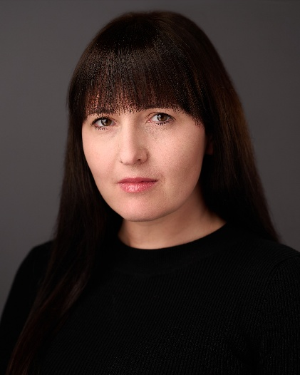
Elle E
07722 552152
elle@elleemodel.com

Spotlight PIN – 3333-5616-0673
Spotlight Link - https://www.spotlight.com/3333-5616-0673
Playing Age: 29-39
Height: 158cm
Appearance: White British
Location: Midlands and London
ACTING ROLES
Year Production Role Company Production Company/
Director
- Television
2024 The Poisoning – How To Tracey Hardwick (daughter) Channel 5 ITN Productions/Craig
Kill Your Husband (True Chambers
Crime Documentary)
- Film
Shorts
2025 Fungus Mona (Lead) Our Little Ayesha Walker (Director)
Productions Joshua King (Co-Director)
2025 The Group Jackie (Lead)/ Co-Producer BOMAD Films Neil Crittenden
2024 If This Is It Sophie (Speaking role) Ambition 45 AJ Chohan
(upset woman) Films
2023 The Haunting of Lisa (Lead) Riverlake Film Sokpov Ung
Valentina Productions
2023 The Undesirables Mother (Ensemble Cast) C-Roll/Clark Thomas Clark
Productions
2022 Therapy Bex (Lead) BOMAD Films Neil Crittenden
2021 The Choice Rebecca Fountain Channel 7 Darren Lalonde
Features
2025 Bone Keeper Nurse Collins Latitude Films Ltd. Howard J. Ford
2021 I Bring Joy Police Officer Canyon Media David Stuart Snell
2021 Barun Rai and The Various character Do It Creative Ltd Sam Bhattacharjee
House on The Cliff voices and dubbing
2021 Shiddat Voiceover and dubbing Maddock Films Ltd Kunal Deshmukh
2020 House of Shadows Receptionist Porcelain Film Ltd Nicholas Winter
- Commercials/Advertising (all as lead talent)
2025 Commercial and Print Customer Turtle Bay Turtle Bay
Restaurant Restaurant
2025 Commercial and Print Customer Cogs Bar and Cogs Bar and
Restaurant Restaurant
2025/ Brand Film and Customer Hoburne Holiday Clearhead
2024 TV Commercial Parks
2024 Commercial Customer and Crew AGCO Vermillion Films
2024 Commercial and Print Customer Avocado Ninja Caan Innovations Ltd
2024 Commercial Student Unite Students Bandstand Ltd
2024 Commercial Swadlincote Town South Derbyshire MIH Solutions
Centre Customer District Council
2023 Commercial and Print Guest Leonardo Hotels Wildish and Co
2023 Commercial and Print Gardener BOSCH Bruizer
2023 TV Commercial Homeowner Cornerstone TriStar TV
2022 Commercial Sarah NGENCO Trevor Bishop
2022 Commercial Mother Janus Henderson Hub Agency
Investors
2022 Internet Towel User ATEN Towels Uniquecapture
(For Amazon)
2022 Internet Tennis Player Zaxcy Sports Bags Uniquecapture
(For Amazon)
2022 Internet Oxfordshire Tourist Fresh Cut Video Harry Pill
2022 Commercial Machine Operator Taski Mulberry Marketing
2021 National TV Commercial Chair User JP Massage Chairs TriStar TV
2021 Commercial Partner LAIBA Beverages LAIBA
2021 Commercial Personal Advisor Barnardo’s charity Tom Taylor
2021 Commercial Plumber’s wife Graham the
Plumbers’ Merchant Stuart Udale
2020 Commercial Lady relaxing at home Elite Drinks Cinergic Media
- Scripted Roleplay
2026 Scripted Roleplay (Ongoing) Patient for University of
(Since doctors’ clinical learning Buckingham/
2022) sessions and OSCE exams Medic To UK/
University of
Nottingham

- Skills/Other
Commercial Actor and Model for lifestyle and general business advertising,
Stage and Screen Combat – Unarmed Combat,
Voiceover and dubbing, Full UK driving license, UK Passport
- Training
2024 2022
Stanislavski Method Training Intensive Unarmed Combat Course and exam (one week) – PASS
Leicester Actors’ Network Workshop ID Fight - for The British Academy of Stage and Screen Combat
Lynsey Johnson, Leicester Stephen Louis, London
2021
Foundation Acting Course (3 months)
The Actor’s Café, John Gould and Abigail Rocchi, London
- Acting Manager and Agent
Darren Vukasinovic
Methodlight Talent
darren@methodlight.co.uk
www.methodlight.co.uk

