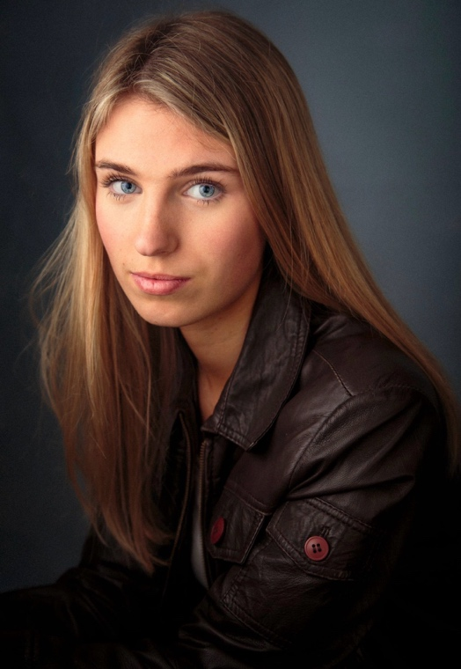
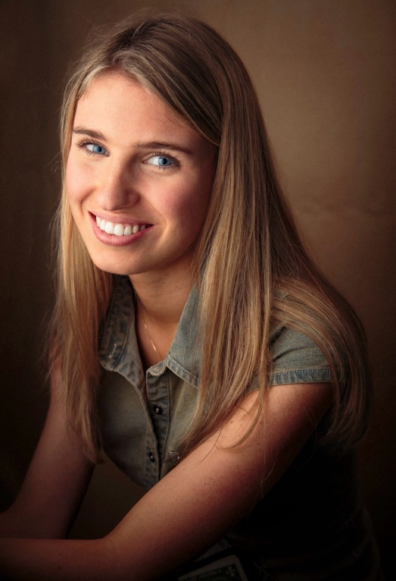
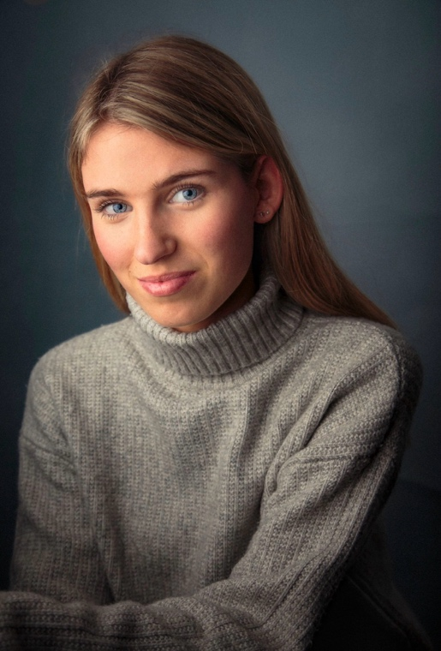
Annabel Snape
annabelsnape@icloud.com
Date of birth: 13.02.2009 - Age 17
Height: 5.6ft, Hair: blonde, Eyes: blue
Address: London

Experience
Television
- Pilot TV Episode: ‘Locals’ 2025 – Manhattan based teen comedy
Played: Jessica (lead role)
Director: Giorgio Arcelli Fontana
Producer: Avi Sach
Release: January/February 2026
Film:
- Feature film: ‘Ducker’ with Malekos Productions.
To play: Misty (lead role)
In production. Completion 2027 – tbc.

- Short film: ‘Mare’ with Opex Films. 2026
Played: Maya (lead role)
Director: Leo Harper Gow
Producer: Leo Harper Gow
Release: tbc

- Short film: ‘Ducker’ 2025*
Played: Misty (lead role)
Director: Joshua Bradbeer
Producer: Nicholas Malekos.
Released: November 2025 onto UK Film Festival Circuit*
*Winner ‘Best Thriller Award’ - London Director’s Independent Festival 2025

- Short film: ‘Hooked’ 2023*
Played: Self
Director: Self
Producer: self
*Winner of GDST short films awards 2024 for cinematography. Also nominated for: best film, story line, actor, and costume.

- Short film: ‘You Are My Mother’ 2022*
Played: Nora (lead role)
Director: Nan Zhao
Producer: Nan Zhao
*Shown at BFI cinema

Theatre
- Performance at His Majesty’s Theatre, singing, dancing and acting 2023
- Musical production “13” March, singing, dancing and acting 2023
- Chamber choir at the Royal Academy of Music at Cadogan hall London. April 2023
- Greenwich Theatre variety performance, singing, dancing and acting
- Finalist in Gadsden acting competition 2022

Training and skills:
- LAMDA, 2017 – 2022 awarded with distinction in each year
- Pauline Quirke Drama and Film school. 2022-2024
- Stagecoach. 2021-2022
- Anna Florentini, Performing Arts School. 2017-2019

