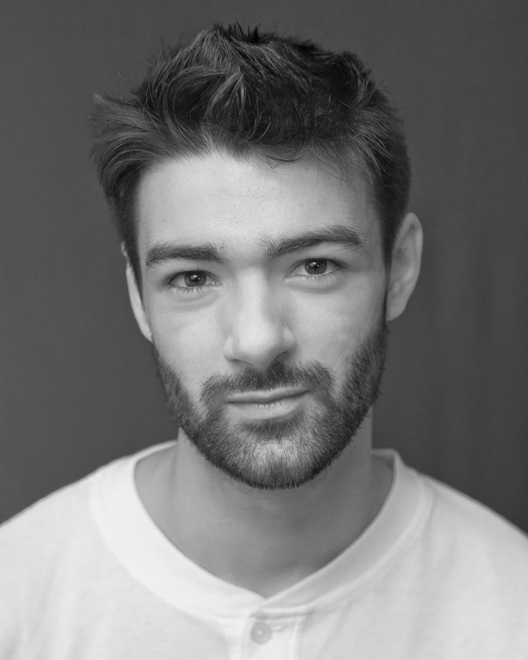
Sam Innes

Email: sam.innes13@hotmail.co.uk
Mobile: 07900141498

Height: 1.80m
Weight: 78Kg
Hair: Brown
Eyes: Hazel
DOB: 13/01/1996
Playing Age: 18-26

Training: BA: Creative and Performing Arts (2:1)
Liverpool Hope University, 2018

Spotlight Pin: 3095-0162-5523
Equity Number: S00455358

Film Credits:

2020: 83- England Cricket player- Kabir Khan (Post Production)

2019: Tolkien – Soldier (Young Man) – Dome Karukoski

2018: Weed Is Illegal – Supporting (Policeman) – Se3studios

2018: To Know Him- Patient- Ted Evans

2017: Frankie – Supporting (The Bartender) – LJLL Productions

2013: The Last Celebrity – Supporting (Mystery Voice) – Wyoming Productions

2012: The Creep - Lead role (Sam) - Student Film

Television Credits:

2019: IIPY- Neville- Mark Wright (Post Production)

2019: The War Of The Worlds – Reporter –Craig Viveiros

Theatre Credits:

2017: Tate Exchange, Liverpool- Auctioneer- Liverpool Hope University

2014: Ubu Roi – Lead role (Ma Ubu) – Richard Waring

Accents:
Home Counties, Essex, Estuary, American Standard, Scottish Standard, and Received Pronunciation

Skills:

Sports
Tennis (qualified LTA coach), skiing (competent), football (local club level), badminton, squash, boxing (Beginner), weight training, clay pigeon shooting

Music

Guitar (Grade 6) Rock and Roll

Vocals (Grade 6) Rock and Roll

Full Drivers Licence-

January 2020

